Cloud server:

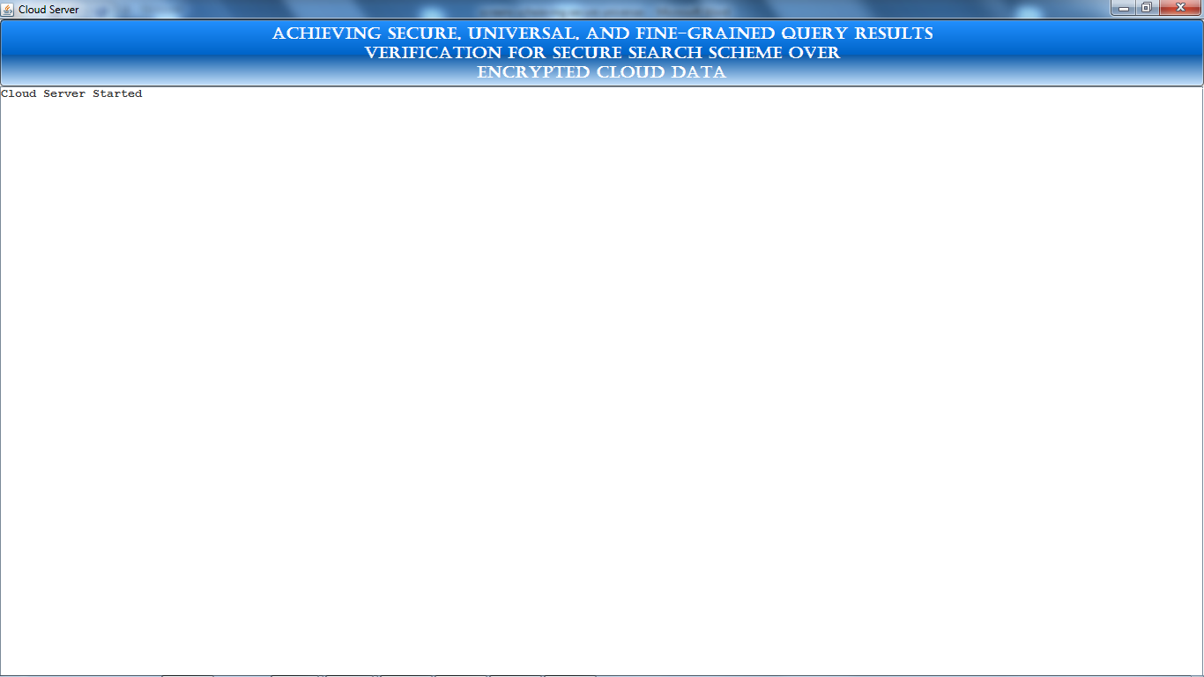

Data owner/ user welcome screen:

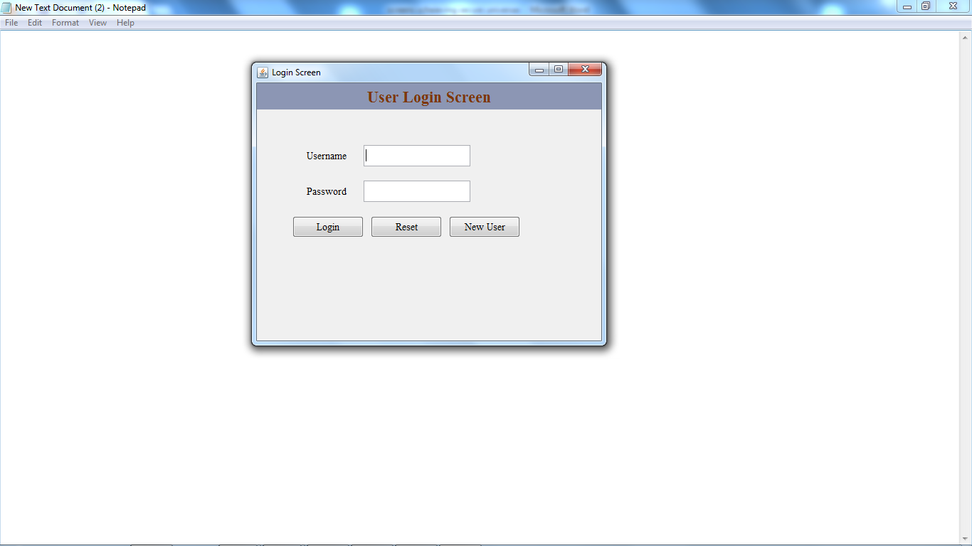

Click on new user to register a data owner:

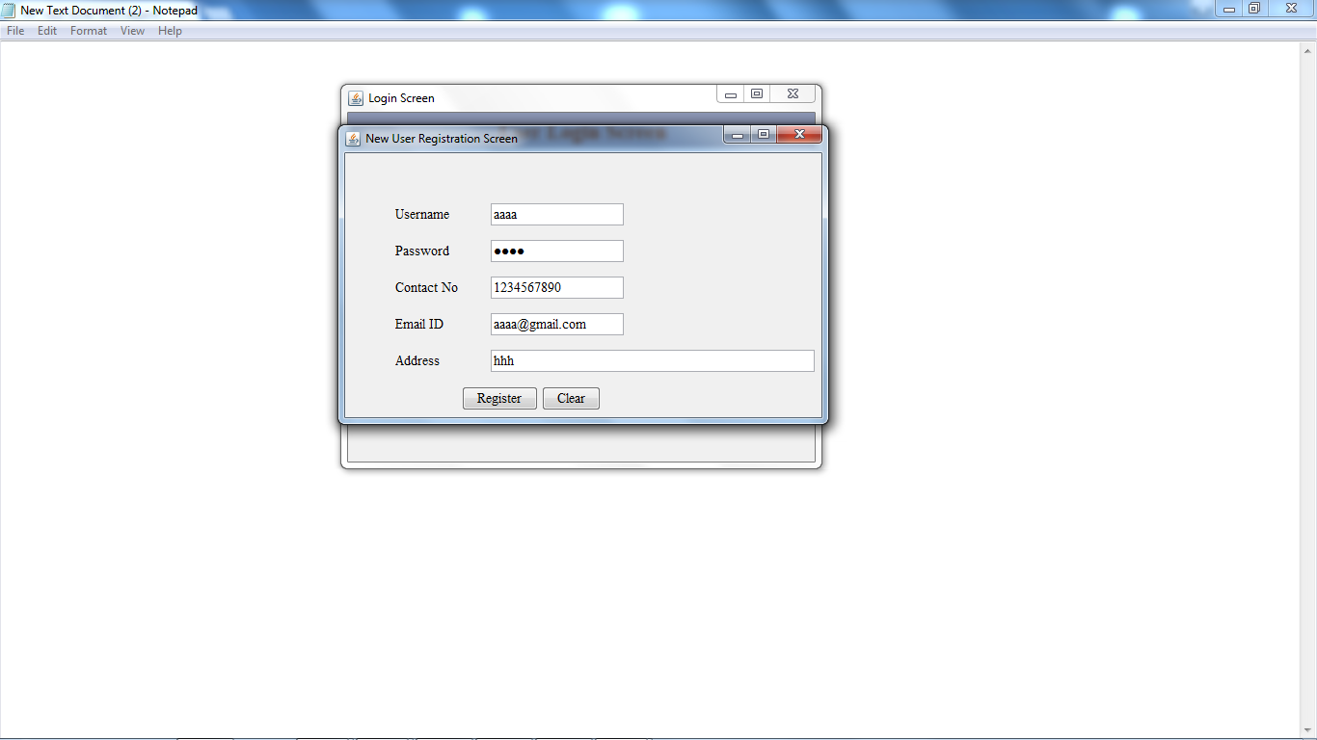

After successfully registering a data owner:

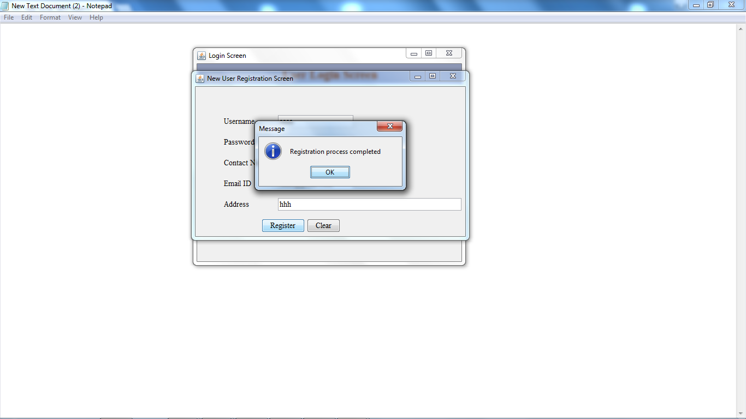

Registering another data owner:

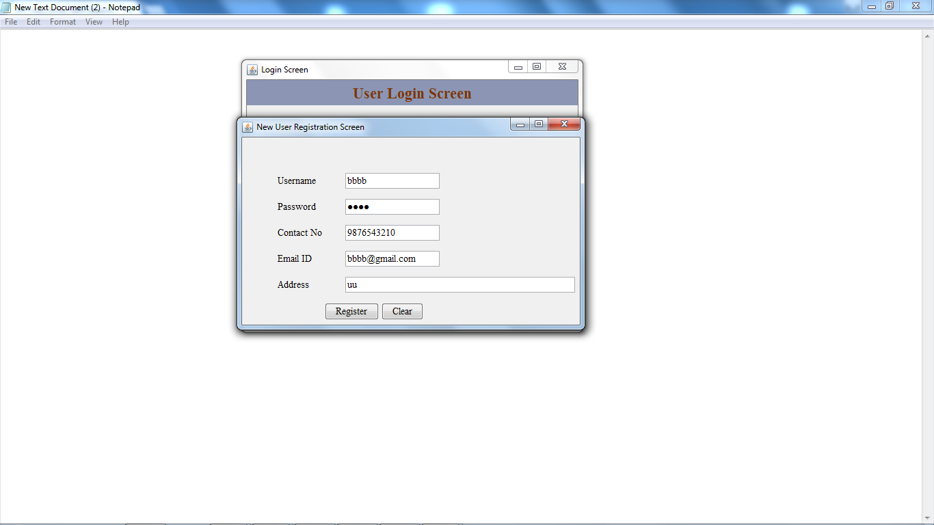

Login as a data owner:

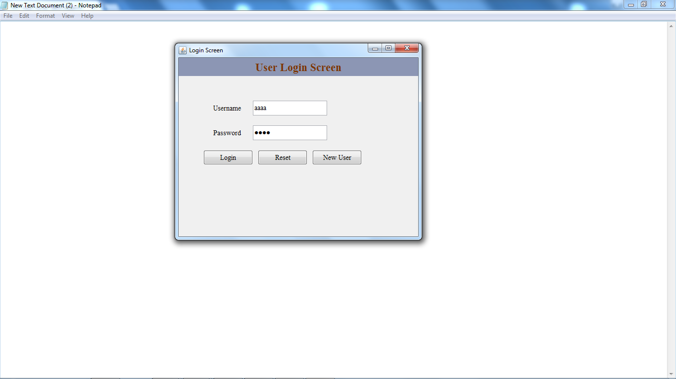

Data owner home screen:

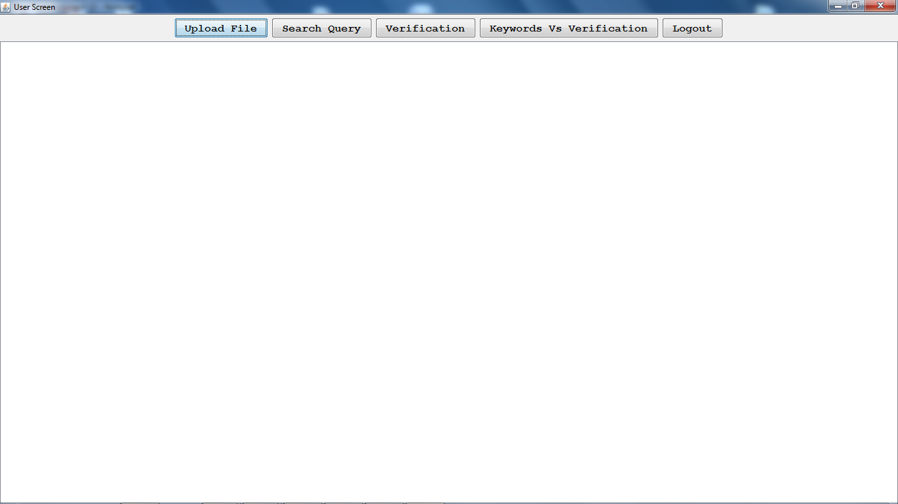

Upload a file onto cloud:

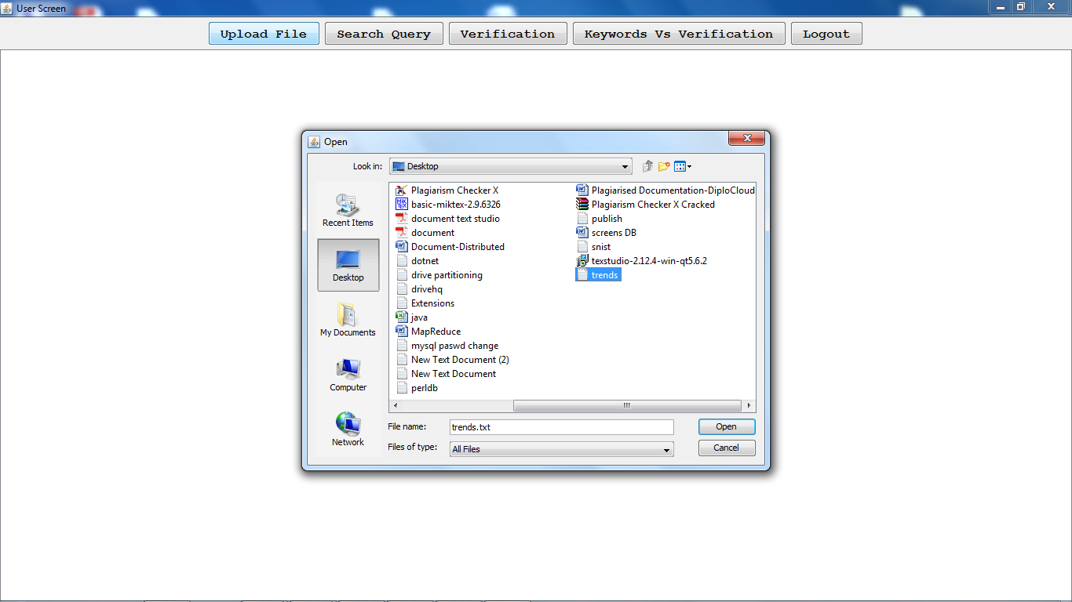

After uploading the file on to cloud

(the generated bloom filter..First for the given word get the bigrams, then generate hash for each bigram by using Paillier Encryption technique then generate some integer value for each hash code (here we are taking the array range up to 50) then generate bloom filter signature)

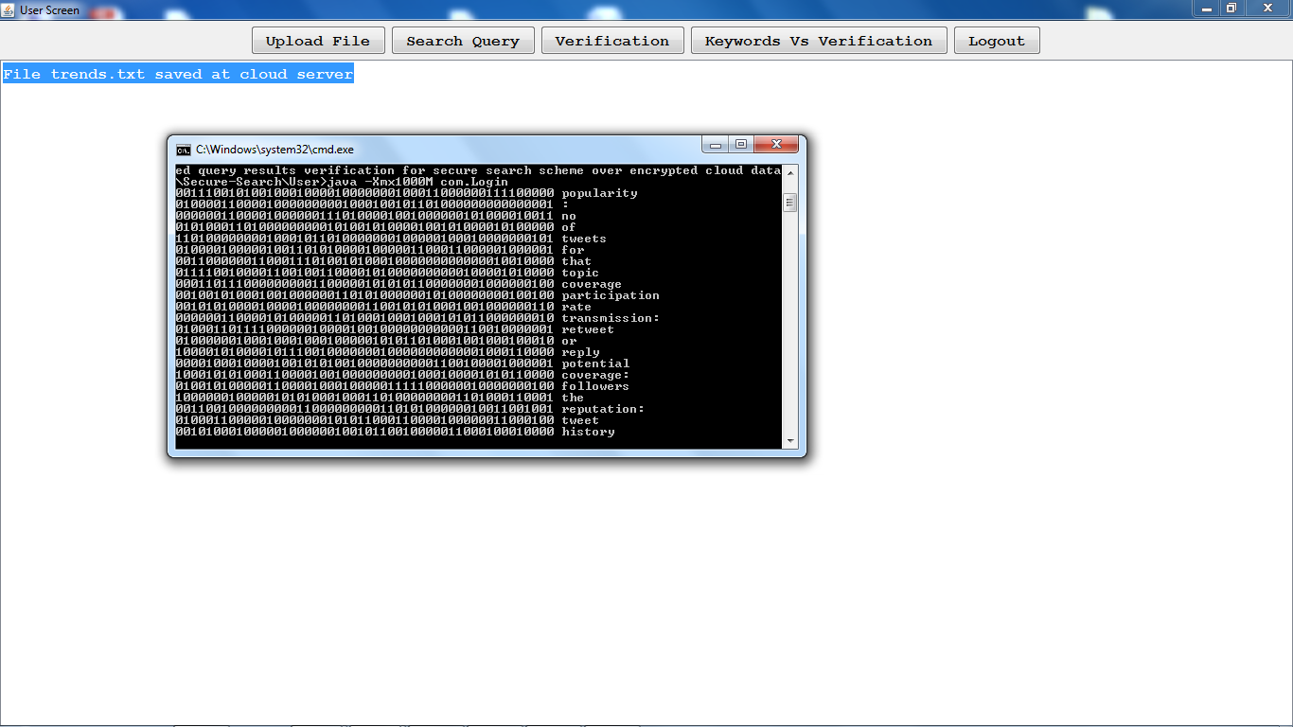

Cloud server after uploading the file: (the file will be saved at cloud in encrypted format by using AES algorithm)

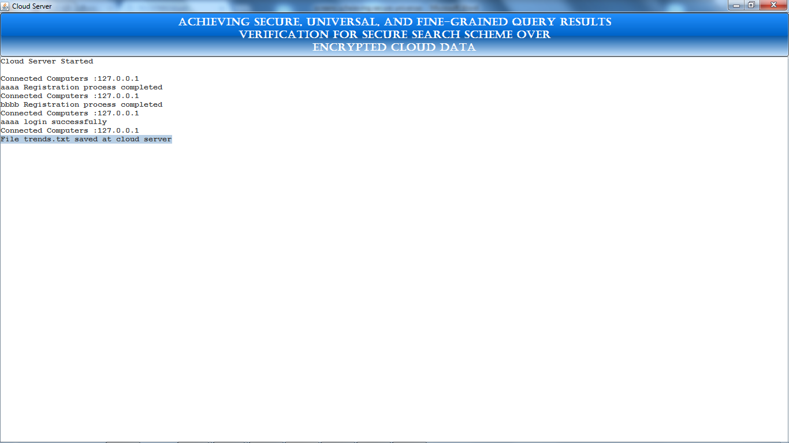

Uploading some other file onto cloud:

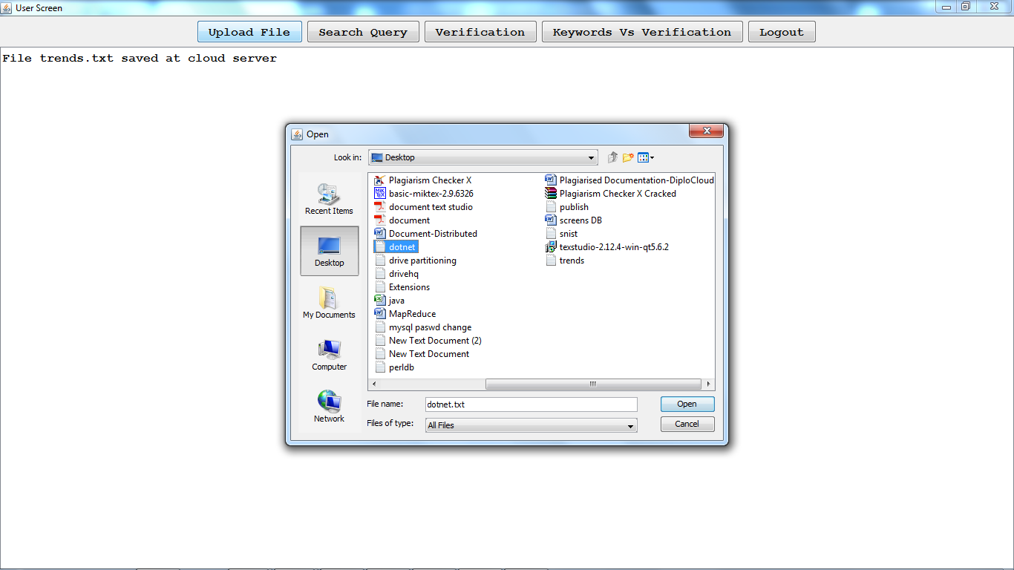

After successfully uploading:

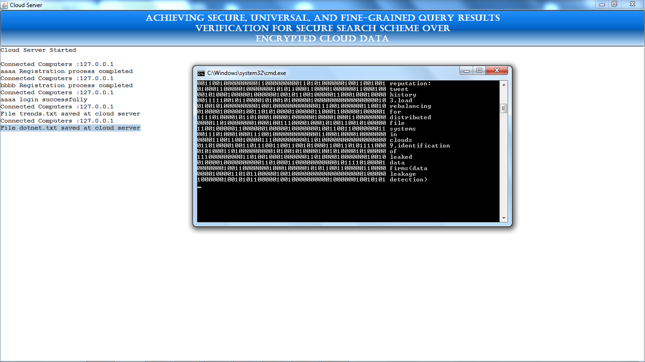

The verification object for the uploaded files will be created and saved at server side:

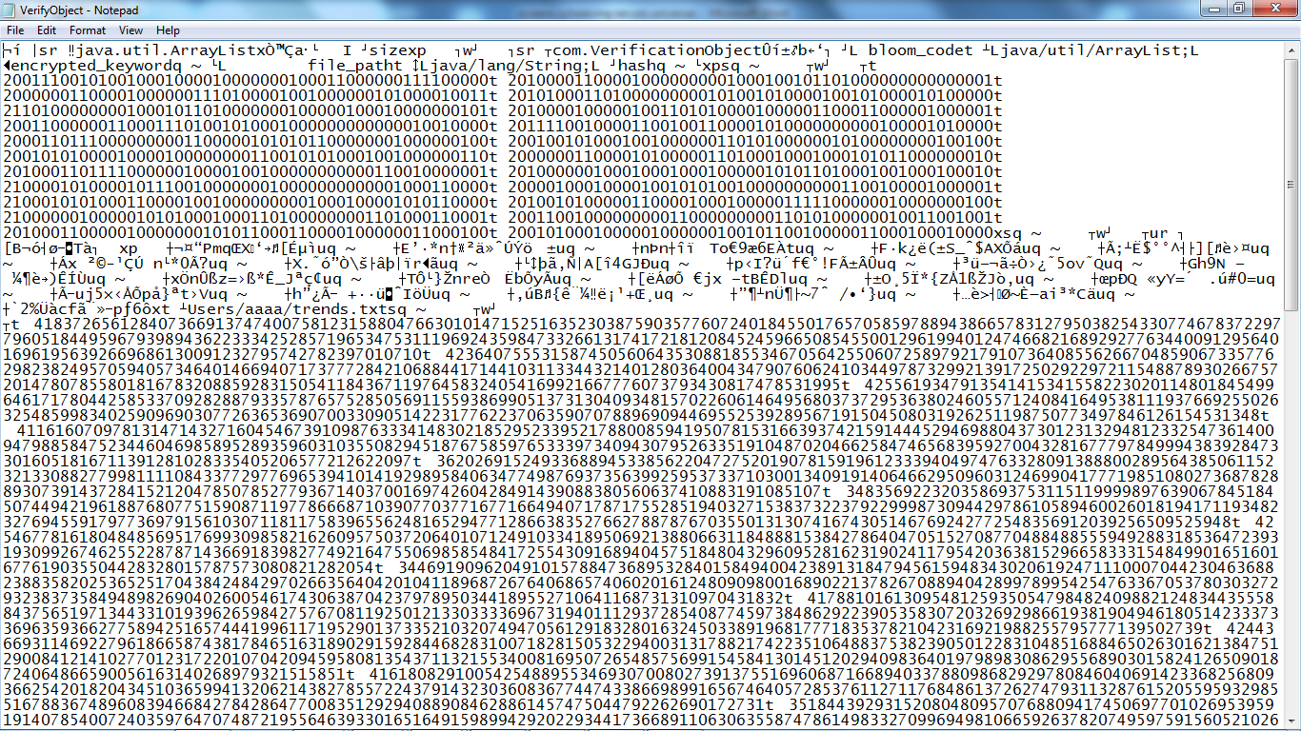

Search query (enter the keywords from both files) (as per this project to reduce the resources, we can give the search results from few of the uploaded files if the client is satisfied with that then he can download that file otherwise he will keep on search until he will receive the required docs)

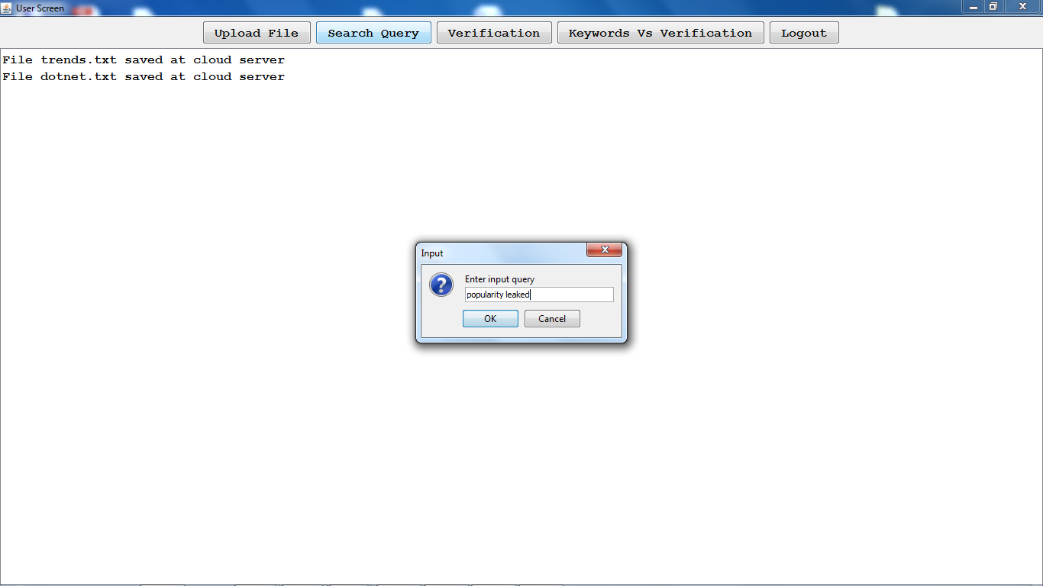

Then for the given query, trapdoor (hashcode) will be generated and searched from verification object for the given hashcode

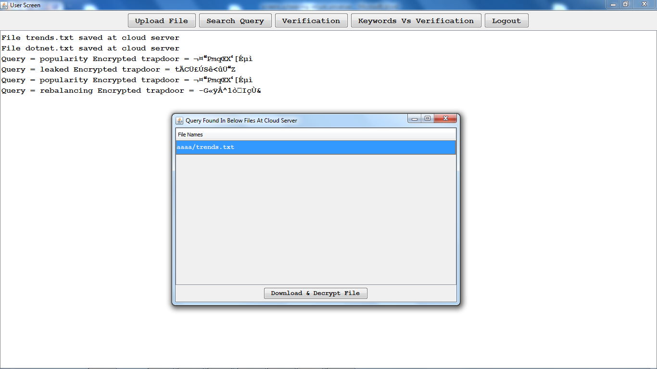

Here it shows the results from one file.

So if the user satisfied then he can download or else he will keep on search until he will get the desire output:

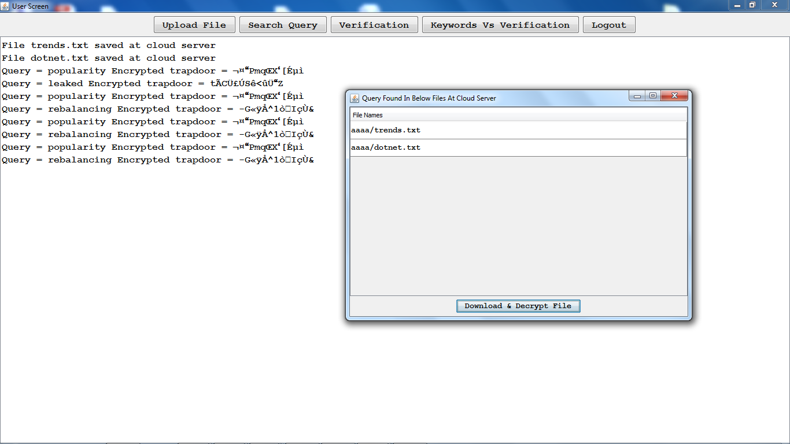

Select the required file and decrypt and download:

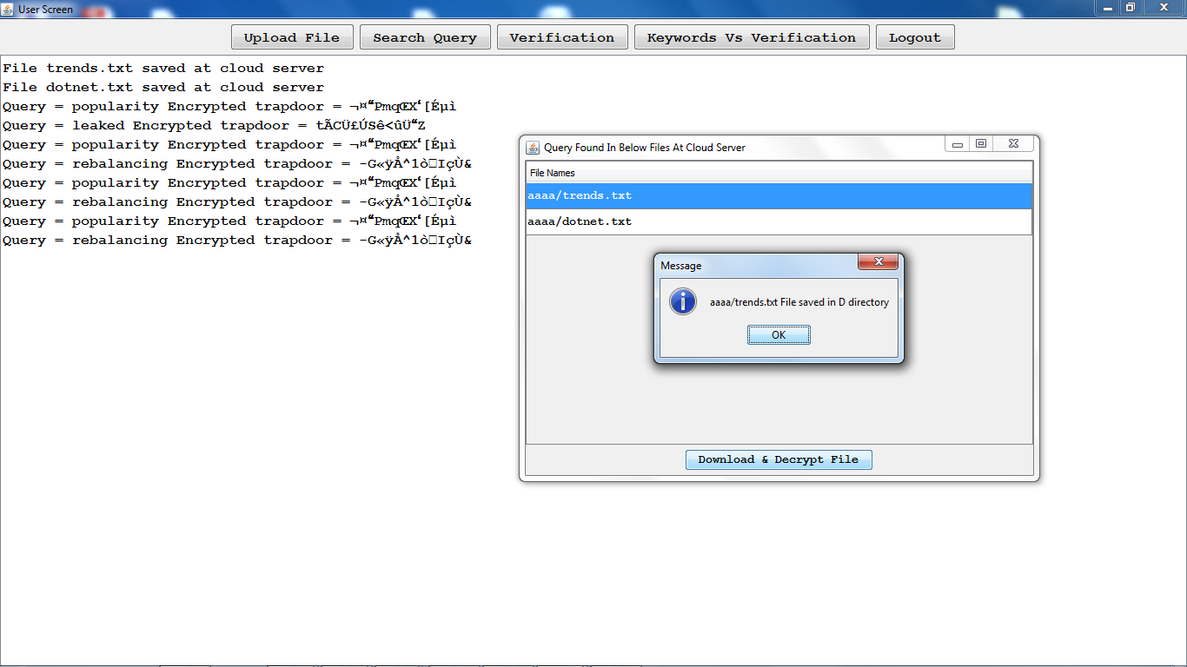

Verification:

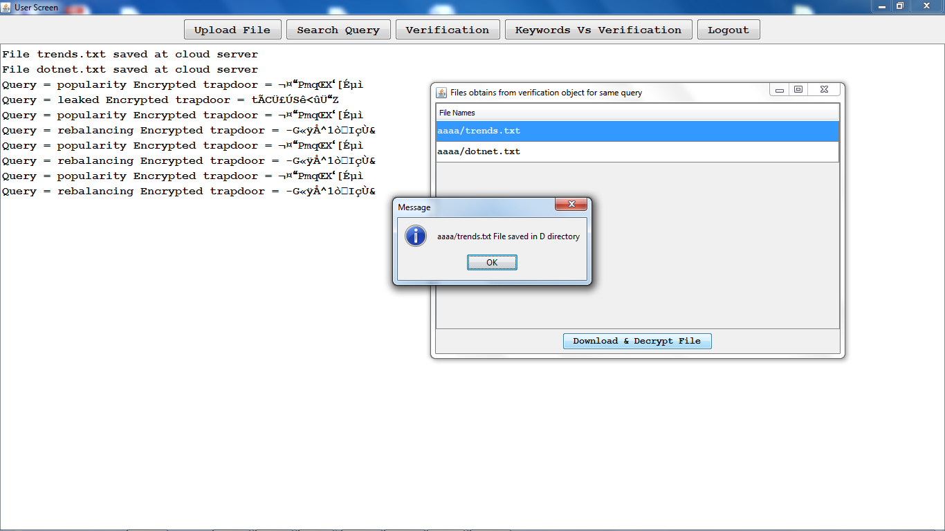

Keywords Vs verification chart:

(how many keywords are there in the uploaded files and how much time it has taken to verify)

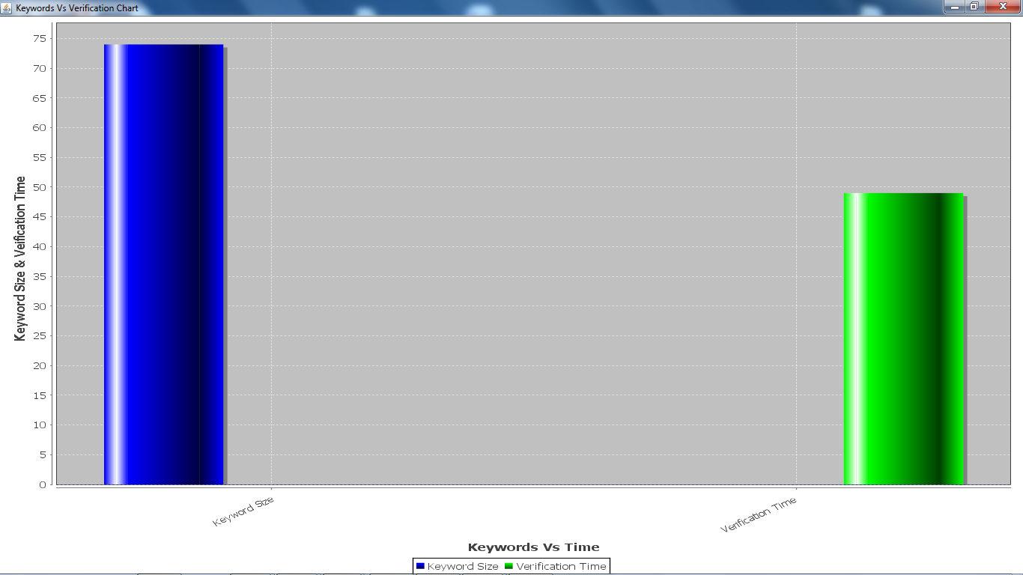

The cloud server:

